Motion and Force in a Gravitational Field

Home Assignment Circular Motion and Universal Gravitation
Name: ANSWERS (48 marks total0

- If a 1.50 kg ball is swung in a vertical circle at a constant speed of 2.40 ms⁻¹. Find the tension in the string at the bottom of the swing if the length of string is 1.20 m. (3 marks)

m = 1.50 kg As in vertical circle, F_{T} = F_{c} + F_{w} [1 mark]
v = 2.40 ms⁻¹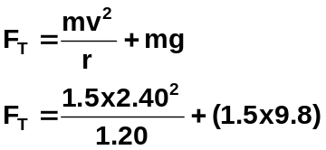
r = 1.20 m

[1 mark]

F_{T} = 7.2 + 14.7
F_{T} = 21.9 N [1 mark]

- While doing his Physics homework, Michael places a cup of milo (mass 0.659 kg) 10.0 cm from the centre of a microwave’s turntable and then turns the microwave on. Why waiting for the milo to heat, Michael notices that the microwave’s turntable spins at 5.0 revolutions per minute.
  - Find the tangential velocity on the cup. (3 marks)

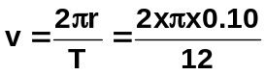m = 0.659 kg
r = 10.0 cm [1 mark]
= 0.10 m
5 rev = 60 s v = 0.05235
1 rev = T v = 5.34 x 10⁻² ms⁻¹ [1 mark]
T = 12 s [1 mark]

  - Find the centripetal force on the cup. (2 marks)
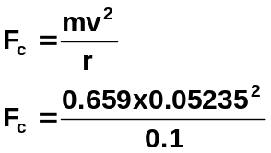

[1 mark]

F_{c} = 0.01807

F_{c} = 1.81 x 10⁻² N [1 mark]

- A railway line goes around a curve of radius 3.50 km. It is designed to carry a very fast train travelling at 360 kmh⁻¹ What would be the angle of banking for the tracks which would result in the best cornering? (3 marks)

r = 3.50 x 10³ m [1 mark conversions]
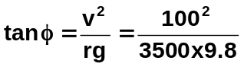 v = 100 ms⁻¹
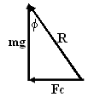
tan φ = Fc = mv²/r [1 mark]
mg mg
tan φ = v²
rg tan φ = 0.2914
φ = 16.3⁰ [1 mark]

- A car is driven around a circular track at a constant speed of 30.0 kmh⁻¹.
  - Is the car accelerating? yes [1 mark]
  - Explain your answer. (2 marks)
As car is going in a circle, direction is always changing so velocity is always changing. [1 mark]
Change in velocity divided by time taken is acceleration so as ΔV, must be accelerating. [1 mark]

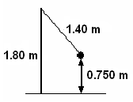
- In a game of totem tennis, a 1.20 kg ball is swung in a horizontal circle at a constant speed on a 1.80 m tall pole. The distance from the ball to the ground is 0.750 m and the length of the rope is 1.40 m. It takes 2.10 s for one revolution of the ball.

  - Draw a free body diagram of the situation and label the forces acting on the ball. (2 mark)

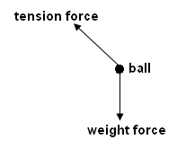

[1 mark forces, 1 mark labels]

  - What is the ball’s acceleration? (3 marks)

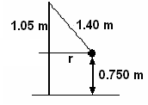
T = 2.10 s 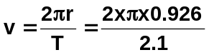
r = 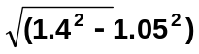 v = 2.77 ms⁻¹ [1 mark]
= 0.926 m
[1 mark] 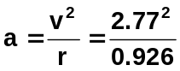
a = 8.29 ms⁻² [1 mark]

  - What is the tension in the rope? (4 mark)
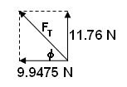
F_{c} = ma_{c}
= 1.2 x 8.29 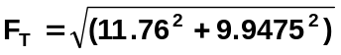
= 9.9475 N = 15.4 N [1 mark]
[1 mark]
F_{w} = mg φ = tan⁻¹ (11.76 ÷ 9.9476)
= 1.2 x 9.8 = 49.8⁰ [1 mark]
= 11.76 N
[1 mark] F_{T} = 15.4N 49.8⁰ to the horizontal as shown in diagram
F_{R} = reaction for to weight
= 11.76 N up
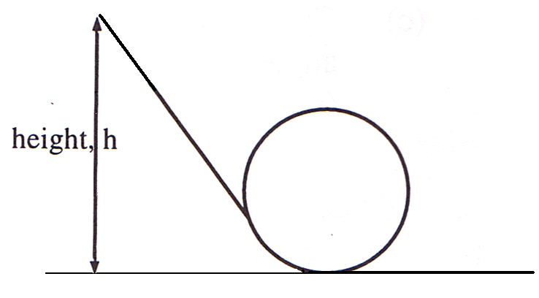
- In a spectacular stunt a motorcyclist, starting from rest, free wheels down a slope and into a loop. At what maximum height must the motorcycle be so that the motorcycle just completes one loop before continuing on. The diameter of the loop is 20.0 m. (4 marks)

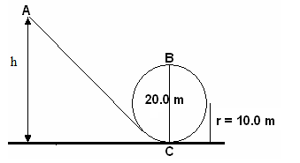
Total energy throughout system is conserved
E_{T} at A = E_{K} + E_{P} but E_{k} = 0 so
E_{T} at A = mgh(A)
E_{T} at B = E_{k} + E_{p}
= ½ mv² + mgh(B) [1 mark]

now as in a circle and need minimum velocity to maintain circle, F_{c} = F_{w} (weight)
so equating formulas: v² = rg at point B [1 mark]

now total energy, E_{T}, is constant therefore energy at A must equal energy at B
mgh(A) = ½ mv² + mgh (B) also v² at B = rg so
mgh(A) = ½ mrg + mgh(B)
g and m will cancel throughout
h(A) = ½ r + h(B) and height at B = 20.0 m so
h(A) = (½ x 10.0) + 20.0 [1 mark]
= 25.0 m

so motorcycle free wheels from 25.0 m [1 mark]

- Sam is on a space-walk around his spaceship to repair a faulty antenna. If his spaceship is 250 km above the Earth, what is the gravitational field strength on him at this point? (3 marks)

r_{T} = r_{E} + r_{O}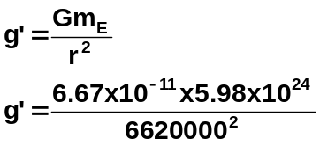
= 6.37 x 10⁶ + 250000
= 6620000 m [1 mark]
m_{E} = 5.98 x 10²⁴ kg [1 mark]

g’ = 9.10 ms⁻² [1 mark]

- The International Space Station will be finished in 2011 and is expected to operate until at least 2015. It has a mass of 344 378 kg and completes 15.7 orbits every day. Its orbit is between 278 km and 460 km but on average about 370 km.
  - Calculate the period of the Space Station. Is it in geostationary orbit? Explain. (3 marks)

15.7 rev = 24 x 60 x 60 [1 mark]
15.7 rev = 86400 s
1 rev = 5503 s
T = 5503 s [1 mark]

It is not geostationary as to be geostationary it needs a period of 24 hours which is
86400 seconds. [1 mark]

  - Calculate the speed of the Space Station and compare it to 27 743 kmh⁻¹ which is given by NASA. (4 marks)

r = 6.37 x 10⁶ + 370000 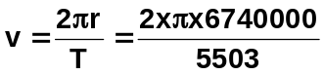 [1 mark]
= 6740000 m [1 mark] v = 7696 ms⁻¹
T = 5503 s v = 7.70 x 10³ ms⁻¹ [1 mark]

given speed = 27 743 kmh⁻¹
= 7706
= 7.71 x 10³ ms⁻¹ calculated value close to actual value [1 mark]

  - Calculate the force of attraction between the Space Station and the Earth. (2 marks)

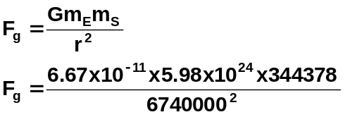

F_{g} = 3023727

F_{g} = 3.02 x 10⁶ N

- A moon of Saturn moves in circular orbit of radius 1.00 x 10⁹ m and period of 1.00 x 10⁶ s. Calculate the mass of Saturn. (4 marks)

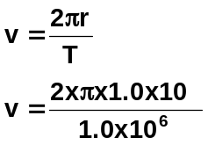  v = 6283  v = 6.28 x 10³ ms⁻¹ [2 marks] | F_{c} = F_{g}  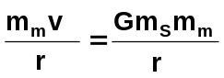 r and m_{m} cancel  m_{S} = 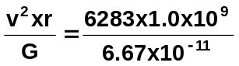[1 mark]  m_{S} = 6.92 x 10²⁶ kg [1 mark]
- Explain, using a mathematical proof, that all geostationary satellites are at the same altitude above the Earth regardless of their mass, then calculate the actual altitude. (5 marks)

T = 24 x 60 x 60  = 86400 s [1 mark]  we know that 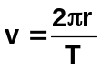  and F_{c} = F_{g} so  v² = 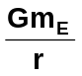 [1 mark]  but as v = 2πr ,  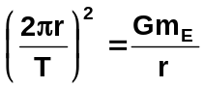  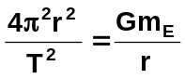  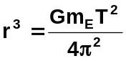 [1 mark] | 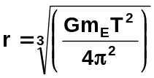  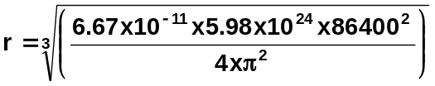  r = 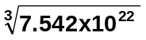  r = 42250207 m [1 mark]  but this is the total r. For r of satellite,  r_{S} = r_{T} - r_{E}  = 42250207 – 6.37 x 10⁶  = 3.59 x 10⁷ m [1 mark]  As can be seen, all satellites orbit at the same altitude as radius is constant and independent of mass of satellite.

